(Approx. 1,555 words)

Media Sharing & Devices
By Jerry Grommes, Editor, Sandwich Computer Users Group, IL
April 2012 issue, SCUG News
www.scug.org

As many of you know I feel strongly that my media, whether it's pictures, videos, music, recorded TV, etc., should be available to me on whatever device I own and not just tied to a computer, CD/DVD player or a DVR. With the increasing number of different kinds devices coming to market, each with its own nitch, I have finally resolved myself to the conclusion that there is not going to be a one size fits all anywhere in the near future.

About three weeks ago Bob Dell sent me a quote from the Tribune's business section (Visions of technology’s future): “Five years from now,” says Nate Williams, Motorola Mobility’s senior director, head of product marketing for the Converged Experiences group, “you’re going to see a dramatic increase in the number of connected devices. The number is about five in the average home now — tablet, gaming console, PC — and it’s going to 15 to 20. You’re going to have a home with more technology and, hopefully, it will be managed in a way that’s a lot more efficient.” I thought that over a bit and started counting. I have eight, which puts me a little above average but less than half of where they are predicting us to be at in the next five years.

Where are you at? Start counting, (Desktop PC, Notebook, Digital Camera, MP3 player, Smart phone, Smart TV, Tablet) that's 7, so you can see, they are adding up fast. Do they all share your media? The answer is yes, but not easily. In my opinion the industry has a long way to go to make it seamless for end users to have their content available across all devices and platforms.

All this lead in was to get to the point of sharing recorded TV and device #9. Ever since migrating from the Commodore to a PC, I have had a TV tuner card in every one of my PCs and if I want to record TV that's how I do it (record it on my computer). From there I can convert the recording to various formats for different devices or burn to DVD. This worked well until the arrival of digital TV. I have cable and they gradually kept dropping the analog channels till it got to the point where I had to add a DTA (Digital Transport Adapter) to the TV tuner in my computer in order to get most of the basic channels again. This happened about the time that I migrated to Windows 7. Since most versions of Windows 7 include MCE (Media Center Edition), I decided to try MCE and found it to be an excellent avenue for watching TV in a little window or for recording TV. The programming guide makes it a snap to schedule recordings.

Device #9
So on to device #9. Two weeks ago I was surfing the channels and found a program that I wanted to record to watch later, problem was it was a High Definition channel which is not broadcast on an alternative digital channel thus I could not record it. Comcast seems to be doing more of this High Definition-only thing lately (not because you get a better viewing experience but rather they can rent you more HD boxes). While watching the show I couldn't record, I grabbed my tablet and started searching for a solution for recording HD on my computer. In a few clicks I was at the Hauppauge web site reading the specs on the WinTV-DCR-2650, a dual tuner CableCARD™ receiver for your Windows 7 PC. I then clicked on the "Features" tab which stated:

WinTV-DCR-2650 is just like a cable TV set top box (a "DVR" box) in that it can be used to watch and record TV from digital cable. There are a couple of differences:
- WinTV-DCR-2650 needs a PC to work. Currently, only a PC with Windows 7 Media Center is compatible with the WinTV-DCR-2650.
- WinTV-DCR-2650 does not have any internal disk storage: it uses your PC for storing recorded TV programs. The nice thing about using your PC for storage is that if you fill up your hard drive with TV programs, you can easily add a new hard drive to your PC.
- WinTV-DCR-2650 records in the original transmitted quality. For example, if you record from an HD channel, the recording will be HD.
- There is no monthly fee for the WinTV-DCR-2650. Once you buy it, it's yours to use forever. But you still need to sign up for cable TV service, and you will still need to rent a digital cable card from your local cable operator.

After reading the 3rd bullet point, that it could record HD channels, I changed my search to a shopping search and had my order placed before the show I wanted to record was even over. How's that for impulse buying?

As you can see from the Quick Setup Guide instructions, there is not much to the setup and installation, it took approximately a half hour to complete the 1st time through. However, I had to repeat step 4 three additional times before everything was fully functional and that took over three hours because after every call I was instructed to wait 45 minutes or more before all the channels would be available. Overall, approx four hours from out-of-the-box to watching and recording High Definition TV on my computer.

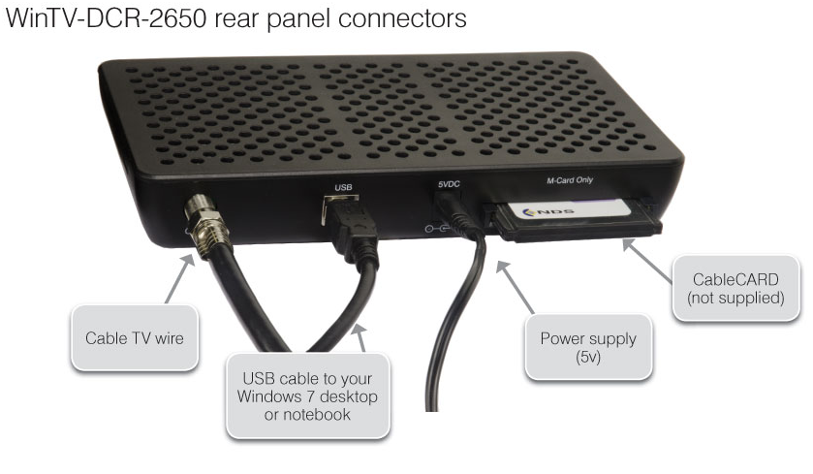
Installation instructions for the WinTV-DCR-2650
Step 1. Run the Windows Digital Cable Advisor to make sure your PC is compatible with the WinTV-DCR-2650.
Step 2. Plug the WinTV-DCR-2650 into your PC via the USB cable. Connect cable TV. Insert the cable card you received from your cable operator into the back of WinTV-DCR-2650.
Step 3. Run the Windows Media Center TV Tuner setup and select your cable TV operator.
Step 4. Call your cable TV company to activate your cable card and “pair” it to the WinTV-DCR-2650

Four calls
In each of the four calls to Comcast a different support person was on the other end, each was very courteous, spoke very good English and seemed very knowledgeable. In the first call the support person activated the card and told me to wait 45 minutes or more before all the channels would be available. After 45 minutes I had all of the digital channels but only the basic (2, 5, 7, & 9) HD channels.

Second call
In the second call the support person said she would resend the activation to the card and told me to wait 45 minutes or more before all the channels would be available. This netted the same results so I ran the Hauppauge diagnostic program that was included on the installation CD. It reported that the firmware on the CableCard was out-of-date and not supported.

Third call
On the 3rd call I gave the diagnostic information to the support person who put me on hold while he collaborated with another technician. When he returned he stated that he would have to flash the firmware of my CableCard and told me to wait 45 minutes or more before all the channels would be available. He also gave me a different phone number to reach a higher level of support if flashing the card didn't work. After my 45 minute wait I retried and had all digital channels but no HD channels (lost ground). I reran the Hauppauge diagnostic and it reported no errors and said all is well.

Fourth call
The 4th call was to the new number given by the last rep and the support person on the other end had all my information from the previous calls and said she would run some diagnostics on the card from her end, after which she said she would reactivate the card asked me to tell her what lights were flashing while she was doing it. While this was going on she said that if this didn't work she would schedule a service call. By the time we were done talking the reactivating had completed and I had all channels (including the HD Channels) that I subscribe to and I didn't have to wait for 45 minutes.

All Channels
I am very pleased with the Hauppauge WinTV-DCR-2650 picture quality; it is very good and since I was already using MCE there was no learning curve. I can receive every channel on my computer that I can get from the Comcast HD Box except On Demand and Pay Per View. With two tuners built-in you can watch one show while recording another. As for media sharing I give it a thumbs up because I can now record a HD TV show and use Windows Live Movie Maker to save it to a format that can be viewed on my Android Tablet.

Hauppauge is headquartered in Hauppauge, NY and has been bringing TV to the PC since 1992. The Company is the worldwide leader in developing and manufacturing PC based TV tuners and data broadcast receiver products. Hauppauge's products allow PC users to watch television on their PC screens, videoconference and create both still video images and digital TV recordings. Hauppauge's flagship product, the WinTV, is the leading branded TV tuner card for PCs.

